Name: ______________________________________ | Date: ___________________

Determining Your Prototype Testing Conditions

When testing a prototype for a protective device, it is important to think about the different ways in which a real object would be used or get damaged. For example, a cell phone would normally suffer damage from a drop of 4 feet or less, so in order to test a protective device for a phone we would want to drop the device from a height of 4 feet or less.

We know that some of the objects that we will be testing protective devices for break easily or are very expensive. Because of that, we will be using something to simulate that material. Engineers call these substitutions proxies. Looking at the following list, think about the shape of your object and the breakability of it. Circle below the proxy object that best fits your testing needs.

Object in real life | Object is thin, flat, and easily damaged. | Object is thin, flat, but not easily damaged. | Object is flat but thicker and not easily damaged. | Object is round and easily damaged. | Object is round and not easily damaged.
Your proxy material | sugar  glass | 2-3 sheets of rice paper | thick sugar glass | an egg wrapped in a small plastic bag | water  balloon

Think about the object you chose above. How will you know it is damaged? What would a little damage look like, a medium amount of damage look like, and a lot of damage look like? Draw diagrams below to show the amount of damage done in different collisions.

What my proxy will look like after experiencing just a little damage | What my proxy will look like after experiencing a medium amount of damage | What my proxy will look like after experiencing a lot of damage

We know that forces are distributed evenly among the objects in a collision, so we can test all objects by dropping them with different amounts of force. We just have to make sure that the amounts of force in a real-life collision would be comparable to our testing situation. Use the decision tree below to determine how you will test your design and how much force to use. Depending on the amount of force needed, you will be either dropping or launching your protective device and object.
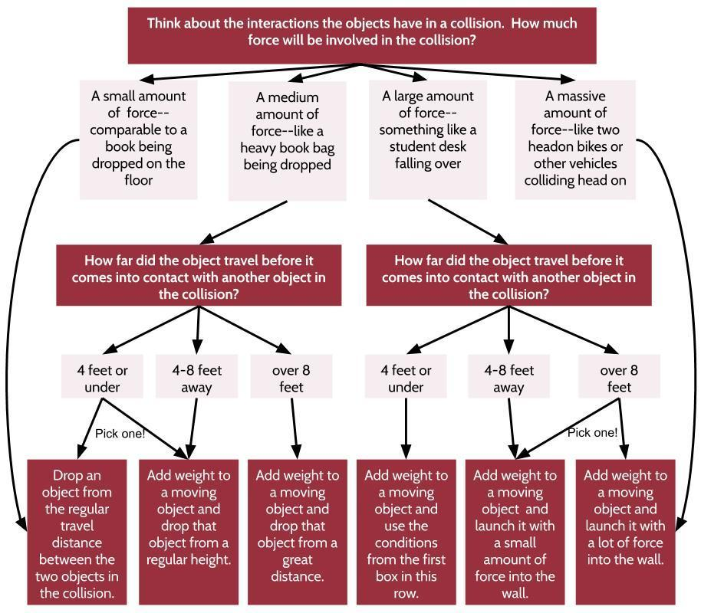

Think about the option above that best fits your testing conditions. What collision factors can you change to ensure equal amounts of kinetic energy are in the system compared to an actual, real-world collision for these objects?

Now that you know how you will test your design and keep it as realistic as possible, let’s begin to piece together a more-precise plan. Use the following chart to determine what will be moving and what will not be moving and the positions of objects in this interaction.

Draw a diagram that shows your protected object moments before a collision. Before the collision, what parts are moving and what parts (if any) are nonmoving? What part or section of your protected object is involved in the collision?
Copy here the diagram you drew in the first row above, but this time modify it to show the protected object in a dropping scenario. In this dropping scenario if any object needs to be hit at a certain angle, show it at the moment of contact with the floor or wall, positioning the area to be hit so that it is directly struck in the collision.

(example: Cell phones normally break when they are hit on a corner, so the phone would be positioned so that the corner would be the main section that comes in contact with another object in the test.)

Draw a recording table below to keep track of your result(s). Check with your teacher to see how many tests can be run in the classroom or elsewhere at school, what materials your teacher has ready to be tested, and how much time you have available. Make sure to include space for multiple trials and any notes that you may want to share with investors.

Indicate how and when in your presentation you will present this information to your investors:

